关于在中南财经政法大学国际学生在线服务系统申请的程序
Application Procedures for the International Student Service System of Zhongnan University of Economics and Law

网上报名：
Login Online Application：

第一步：输入在线报名网址 http://iesmis.zuel.edu.cn/member/login.do
Step One: Type in online application website：http://iesmis.zuel.edu.cn/member/login.do
第二步：进行网上用户注册,填写注册信息，点击“立即注册”，带*为必填
Step Two: Register online，*is the necessary information
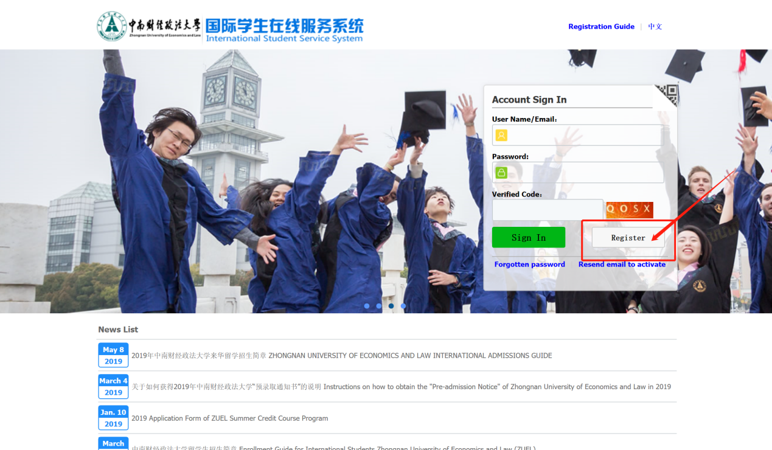
第三步：激活邮箱，点击注册激活链接
Step Three: Activate the mailbox, click on the registration activation link
第四步：进行申报：
Step Four: Applying online,
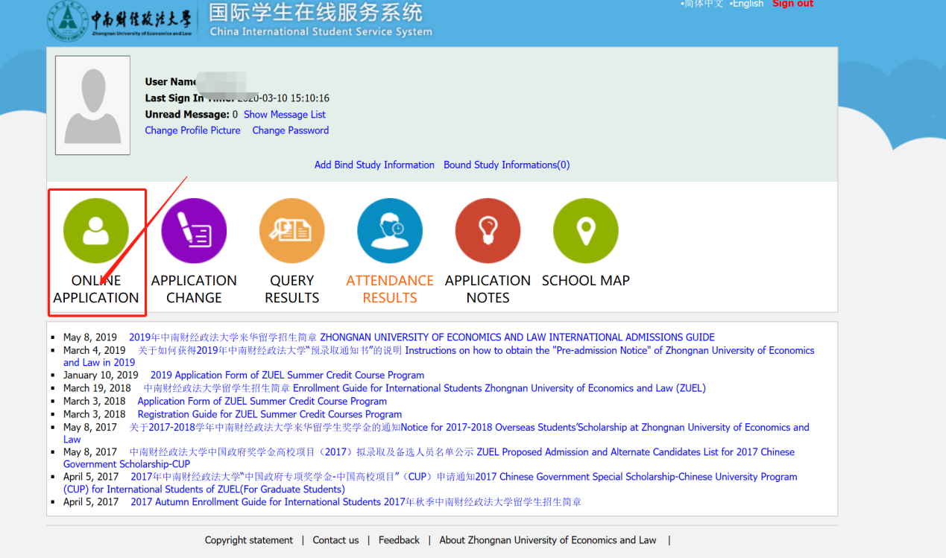
选择学习项目 “中国政府奖学金”，点击下一步
choose your program ‘Chinese Government Scholarship’ and click on “next”
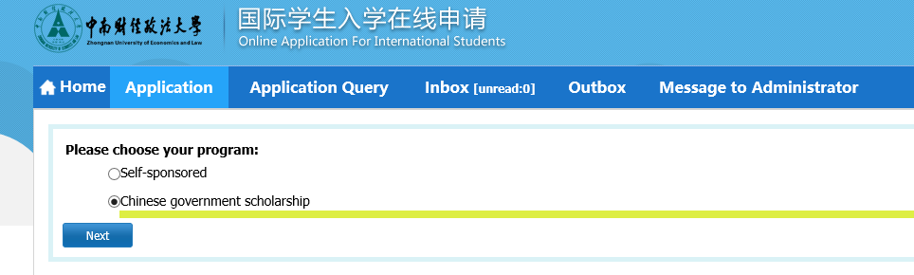
选择学生类别“硕士研究生”，点击下一步
choose your type ‘Master Student’ and click on “next
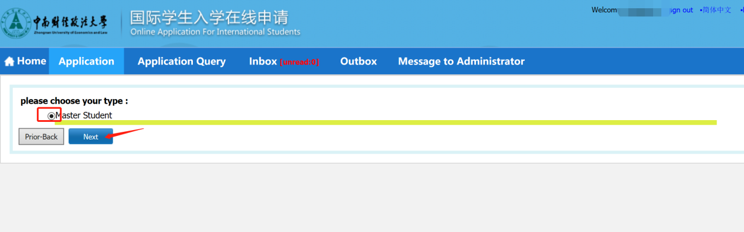
选择“法学院，知识产权法，英语”点击“申请”
choose “department: Law School、major: Intellectual Property Law、teaching language: English” and click on “Apply”
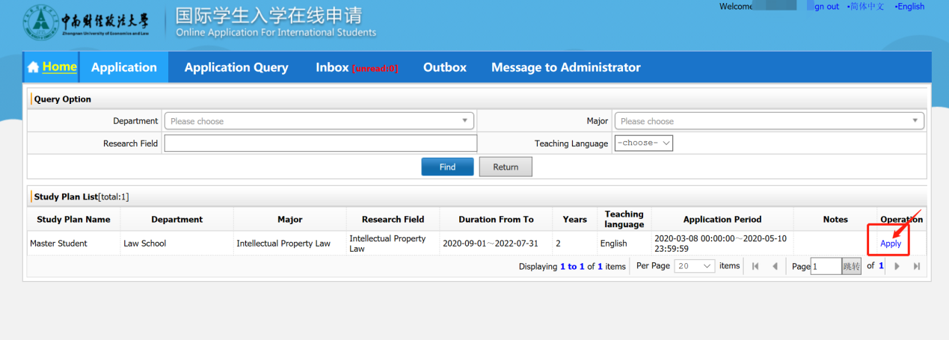
第五步：完整填写相关内容，按要求上传相应申请资料，提交电子报名信息。
★ 请确保提供的信息和材料真实无误，材料不符合要求将被拒绝。
Step Five: Complete the information, upload all the required documents and submit your application.
★Please make sure all information and documents are true and valid. Uncompleted application would be rejected.
