Wuhan Electric Bicycle Electronic Driving License Upload Guide

- Follow 武汉交警 (Wuhan Traffic Police) WeChat official account
- Click on V用户

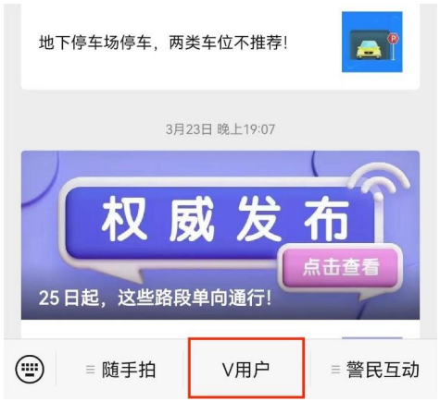

- After entering, please select 【电动自行车行驶证】(Electric Bicycle Driving License) from the section 其他业务 (Other services)

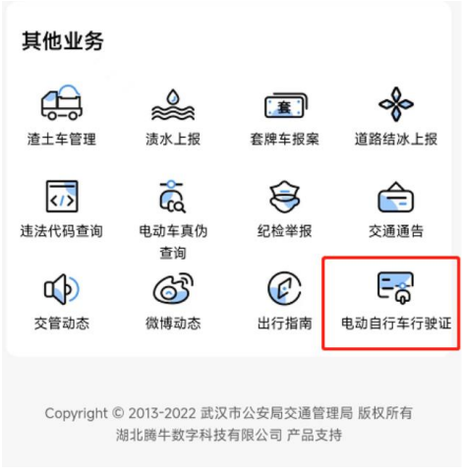

- After carefully reviewing the instructions for the electric bicycle driving license (electronic version), click on 【开始使用】(Start Using') and then click on 【绑定车辆】(Bind Vehicle) on the vehicle management page (车辆管理).

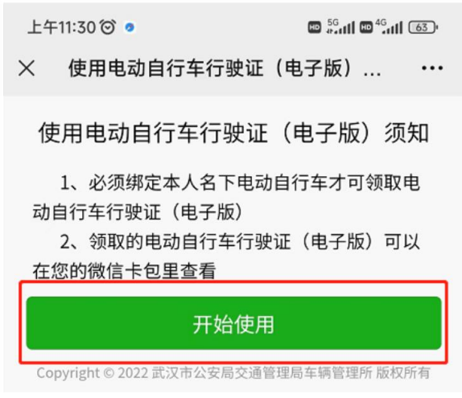
Start using

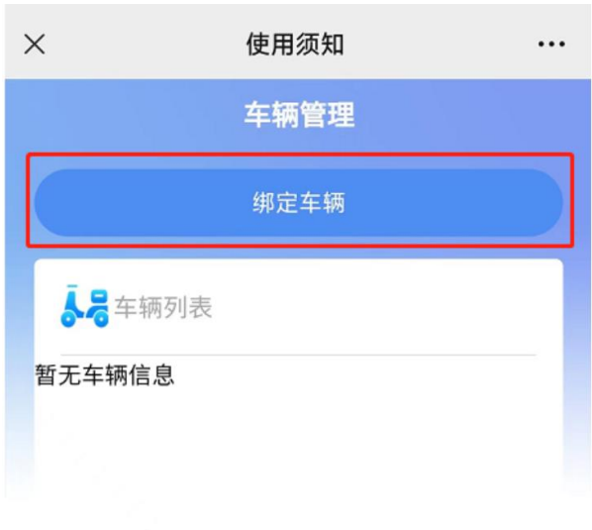
Bind vehicle

Attention: to obtain an electric bicycle driving license (electronic version), it is necessary to bind the electric bicycle under one's own name, which means that the owner of the electric bicycle must have the same real name authentication information as the Wuhan traffic police.
- Select 【个人车辆】 (Personal Vehicle) and enter the vehicle license plate number as required to complete the binding.

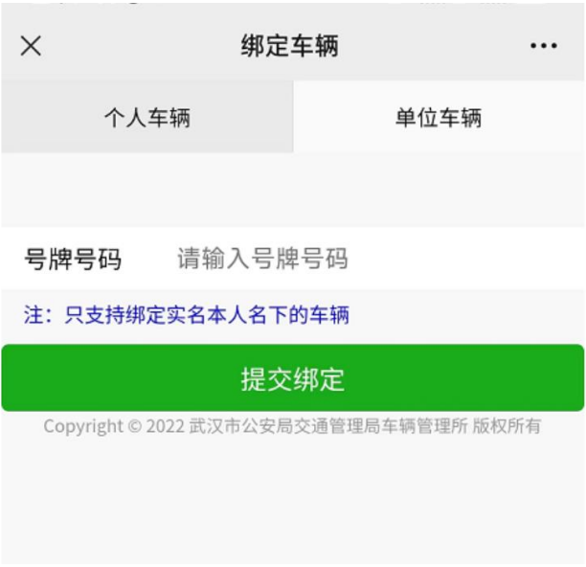
Submit binding
License plate number
Personal vehicle

- After completing the vehicle binding, you can view the electric bicycle information under your name in the 车辆列表(Vehicle list).

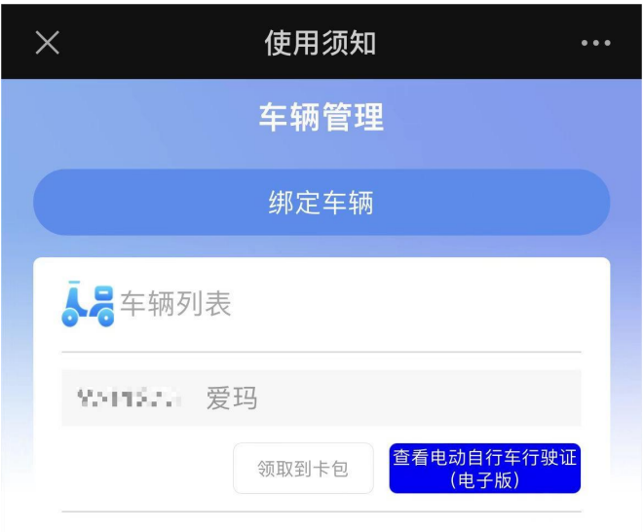
Vehicle list
- Click to view the electronic version of the electric bicycle license, and upload a screenshot.

